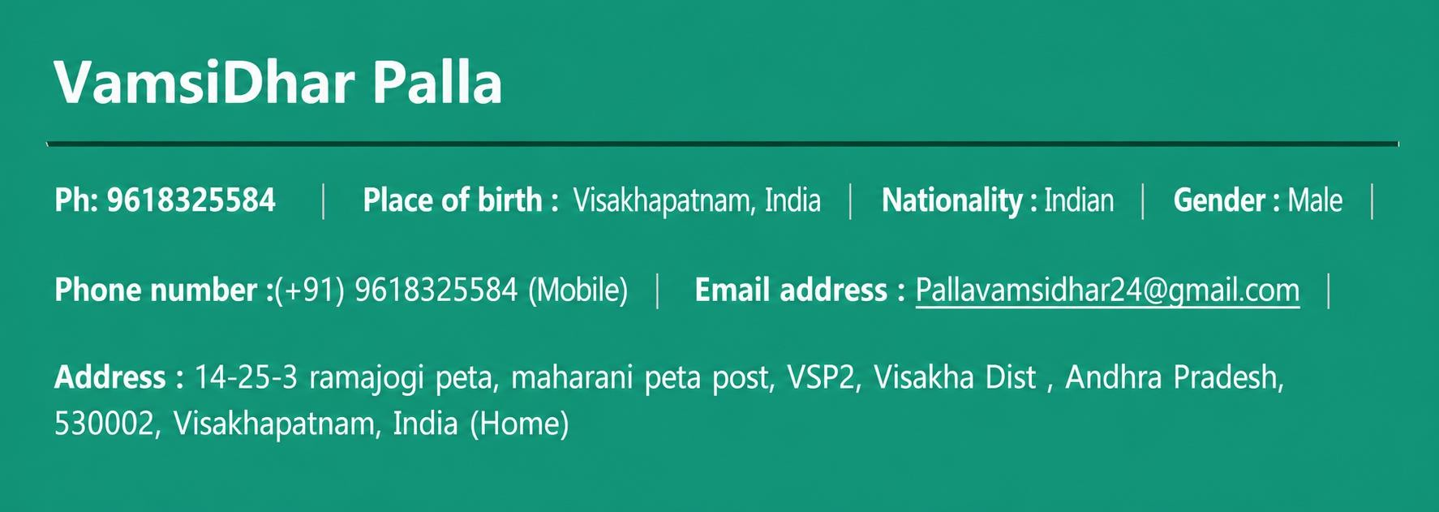



Experienced Azure/GCP DevOps / SRE professional. with 5 years of hands-on expertise Proficient in designing and managing cloud infrastructure, implementing CI/CD pipelines, and automating deployment processes. Skilled in optimizing system reliability and performance. Committed to delivering efficient and scalable solution.

–

Main activities and responsibilities
- Configure and maintain cloud infrastructure across AWS, Azure, and GCP, including VPC/subnet creation, role-based access control, and instance management.
- Troubleshoot and resolve issues in CI/CD pipelines built on GitLab, ensuring smooth and consistent deployments.
- Administer Kubernetes clusters, monitor workloads, and automate deployments using Helm, Ansible, and Terraform,Shell Scripiting..
- Handle database support tasks such as managing MySQL and PostgreSQL instances, backups, and performance tuning.
- Create and manage VM snapshots and ensure backup/recovery processes are properly implemented.
- Monitor infrastructure health using LogicMonitor and respond to alerts to maintain high system availability.
- Implement and maintain infrastructure-as-code (IaC) using Terraform and configuration management with Ansible.
- Collaborate with security teams to manage firewall configurations, certifications, and compliance requirements.
- Work closely with cross-functional teams via ServiceNow for incident, problem, and change management.
- Manage user-raised tickets related to infrastructure, application packaging, firewalls, disk allocation, certifications, and instance provisioning.
- TRITECH SOFTWARE PVT LTD – HYDERABAD, INDIA
DEVOPS ENGINEER – 10/08/2019 – 12/02/2024
  - Experienced in creating and deleting repositories and branches in GitHub, managing users, organizations, teams, and groups, and implementing branch protection rules to secure code.
  - Designed and built CI/CD pipelines using Jenkins, including multibranch pipelines for automated build, test, and deployment workflows.
  - Managed IAM users, roles, and policies in AWS, granting least-privilege access and ensuring security best practices.
  - Hands-on experience with Docker for containerization and deploying microservices in Development and QA environments.
  - Skilled in deploying and managing microservices on Kubernetes, including cluster setup and management for both on-premises and cloud environments.
  - Experienced in writing and managing Kubernetes objects such as Pods, Services, Deployments, and Ingress to ensure smooth application delivery.
  - Managed Docker containers using Kubernetes, including scheduling, scaling, and rolling updates of containerized workloads.
  - Collaborated with development teams to write Dockerfiles, integrate Docker builds in Jenkins jobs, and automate tagging and image management.
  - Implemented Ansible for configuration management to automate repetitive tasks, deploy critical applications, and maintain infrastructure consistency.

  - Configured and automated Ansible playbooks for provisioning and managing existing infrastructure.
  - Hands-on experience with Terraform for Infrastructure as Code (IaC) to build, modify, and version infrastructure efficiently.
  - Created and managed AWS resources using Terraform, including EC2, IAM, ELB, Security Groups, S3, and EKS.
  - Developed Terraform templates to automate the provisioning of complete Kubernetes infrastructure across environments.
  - Utilized Terraform execution plans and state management to ensure predictable and safe infrastructure changes.
  - Created and configured S3 buckets with appropriate policies for secure data storage and access management. Implemented AWS backup and recovery strategies using snapshots and AMI creation to safeguard data and instances.
  - Managed IAM users and groups, assigning individual policies and enforcing access control across AWS resources.

PROJECTS
15/02/2024 – CURRENT

Carrefour

Carrefour's projects in Spain focus on an omnichannel, digital-first strategy that includes opening new stores, acquiring competitors, and integrating online and physical retail experiences. Key initiatives involve developing e-commerce hubs, converting acquired stores to various Carrefour banners, and enhancing the customer experience through a single app for both online and in-store services.
10/08/2019 – 12/02/2024

NAVAL DOCKYARD

As major part of Sears business is based on Ecommerce site should be available all the time Our team job is to build and release code for deployment on appropriate servers to Deployment team. Site will be developed in production

EDUCATION AND TRAINING
15/06/2015 – 27/04/2017 Visakhapatnam, India
M.TECH Sri Chaitanya college

Address 523316, Visakhapatnam, India
24/07/2011 – 15/06/2014 Andhra Pradesh, India
BACHELOR OF TECHNOLOGY Jawaharlal Nehru Technological University Kakinada

Mother tongue(s): TELUGU
- Other language(s): ENGLISH | HINDI

